|  |  |
| --- | --- |
| *Pacific Gas and Electric Company* | |
| Patch 7.6.7 Installation Guide | |
|  |  |
|  |  |
| Project | ED AM/GIS |
|  |  |
| Prepared by | Ashish Narasimham, Brittany Roderman |
| Date | 9/26/2013 |
| Version | 1.0 |
| Version Type | Final |

|  |  |  |  |
| --- | --- | --- | --- |
| Revision History | | | |
| Document # | Date | Author | Summary of Changes |
| 1.0 | 9/25/13 | Ashish Narasimham, Brittany Roderman | Initial Document Creation |

# Introduction

## Purpose

This document is intended to detail the implementation and configuration steps required to implement Patch 7.6.7 Installation Guide. This document describes the various configuration aspects required to complete any manual or automatic patch associated with this release. Each section in this document contains the steps required to patch the system in production.

## Terms Used

|  |  |
| --- | --- |
| OOTB | Out of the box. Unmodified from the commercial version. |
| TFS | Team Foundation Server |

## External Documents

Referenced are any external configuration documents or exports. These are documents that contain more detailed information about configuring a system or documents that can be loaded into an application to perform the configuration detailed in this document.

1. Connectivity rules XML
   1. Location: \\sfetgis-nas01\sfgispoc_data\ApplicationDevelopment\IBM_Delivery\Production Release 7\Data Model
   2. File name: 7_6_7_Connectivity_Rules.xml

## List Of Fixes

Below is the list of change requests detailing all fixes for the data model for this release:

|  |  |  |  |
| --- | --- | --- | --- |
| **Item Number** | | **Title** | **Work Item Type** |
| [10155](http://edappgistfsprd1:8080/tfs/ElectricDistCollection/EDAMGIS/_workItems#_a=edit&id=10155) | | Data Model Release 7.6.7 | Change Request |
| [10173](http://edappgistfsprd1:8080/tfs/ElectricDistCollection/EDAMGIS/_workItems#_a=edit&id=10173) | Create Session History trigger | Change Request |
| [10156](http://edappgistfsprd1:8080/tfs/ElectricDistCollection/EDAMGIS/_workItems#_a=edit&id=10156) | Connectivity Rules Update | Change Request |

## Summary of Steps to Complete Patch

These are the high-level steps to complete the installation and configuration of the data model patch. Use this table as a guide for completing the installation. Links are provided that can lead either within the document for detailed explanations or to external sites such as Sharepoint.

|  |  |  |  |
| --- | --- | --- | --- |
|  | **Step Name** | **Description** | **CR (if applicable)** |
|  | Open a Database Connection | Open a database connection in ArcCatalog | - |
|  | Create Session History Trigger | Run SQL to create a trigger for Session History | [10173](http://edappgistfsprd1:8080/tfs/ElectricDistCollection/EDAMGIS/_workItems#_a=edit&id=10173) |
|  | Connectivity Rules Update | Import XML to update connectivity rules | [10156](http://edappgistfsprd1:8080/tfs/ElectricDistCollection/EDAMGIS/_workItems#_a=edit&id=10156) |
|  | Update Data Model Version Table | Update the data model version table to reflect this update | - |

# Open a Database Connection in ArcCatalog

1. Open ArcCatalog.
2. Within the Catalog Tree, expand “Database Connections” and open the active connection for this process. This is the connection that is referenced in the change request associated with this document (EDGIS<DB name in the format X#Y> )

# Create Session History Trigger

Follow the below steps to create a new table that will hold all session history and will not be deleted when a session is deleted and then create a trigger that will populate this table.

1. Create the PGE_Session_History table
   1. Log into sql plus with the EDGIS user.
   2. Run the following query:

CREATE TABLE PGE_SESSION_HISTORY(  
 NODE_TYPE_ID NUMBER(38) ,  
 NODE_ID NUMBER(38) ,  
 SERVER VARCHAR2(128) ,  
 USER_ID NUMBER(38) ,  
 USER_NAME VARCHAR2(32) ,  
 DATE_TIME DATE ,  
 DESCRIPTION VARCHAR2(255),  
 EXTRA_DATA VARCHAR2(255));

grant all on PGE_SESSION_HISTORY to mm_user;  
grant all on PGE_SESSION_HISTORY to mm_admin;

1. Create the insert trigger that will populate the table just created.
   1. Log into sql plus with the process user.
   2. Run the following query.

CREATE or REPLACE TRIGGER PGE_SESSION_HISTORY_TRIGGER  
AFTER INSERT  
 ON PROCESS.MM_PX_HISTORY  
 FOR EACH ROW

BEGIN

 -- Insert the new row from MM_PX_HISTORY table into PGE_SESSION_HISTORY table for permanent history  
 INSERT INTO EDGIS.PGE_SESSION_HISTORY  
 (NODE_TYPE_ID,  
  NODE_ID,  
  SERVER,  
  USER_ID,  
  USER_NAME,  
  DATE_TIME,  
  DESCRIPTION,  
  EXTRA_DATA)  
 VALUES  
 (:new.NODE_TYPE_ID,  
  :new.NODE_ID,  
  :new.SERVER,  
  :new.USER_ID,  
  :new.USER_NAME,  
  :new.DATE_TIME,  
  :new.DESCRIPTION,  
  :new.EXTRA_DATA);  
END;  
/

# Connectivity Rules Update

Import an XML configuration into the database to update connectivity rules

Before performing this step, please ensure that you have the connectivity rules patch (originating from Vinay) installed locally. Without this, performing this step will break the system.

1. Open the Geodatabase Designer toolbar in ArcCatalog.
2. Click the Output Window button on the toolbar to view the Output Window. 
3. Click the XML tab and click Open.  
   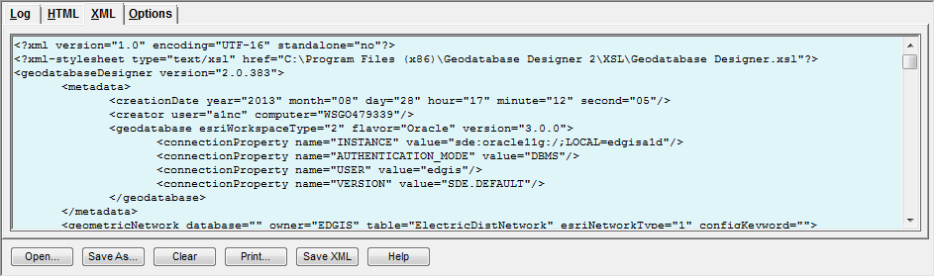
4. Copy/paste the filepath referenced in Section 1.3 of this document (titled External Documents) into the File Explorer window and select the Connectivity file in that folder (name referenced in Section 1.3 of this document).

1. Select the drop down on the toolbar of “Import Schema” ->Import From XML from the Designer toolbar to start the process. The streaming output will appear in the Log tab. When it displays some form of the following sentence, you are done:



# Update Data Model Version Table

**Database Configuration:**

1. Open SQL Plus.
2. Log in using the same server and user as was used in section 2.  
     
   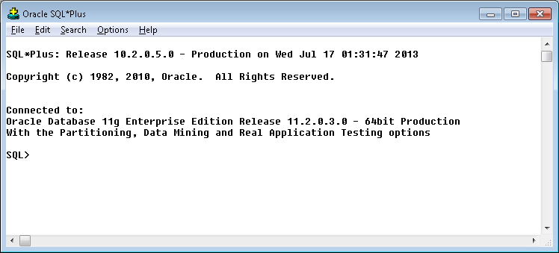
3. Run the SQL below:

update pgedatamodelversion set currentidc='N' where currentidc='Y';

insert into pgedatamodelversion (OBJECTID, CURRENTIDC, DATEAPPLIED, APPLIEDBYPERSONNAME, MODELVERSION) values (**39**,'Y',sysdate,'**<INSERT TEAM MEMBER DONE BY>**','**7.6.7** GOLD **CR10155**');

commit;

# Known Issues

<Please List any other issues encountered here while following the document>